NAME: Debatwik Santra Roll No: CSE /23/110 Exam Roll No: 11600223047
Assignment No-3: Create IAM User and Grant Full Access to Amazon S3.
Solution:
Step 1: login to AWS Console
- Open the AWS console login page.
- Login using Root User Credentials.
- Open AWS Management Console.
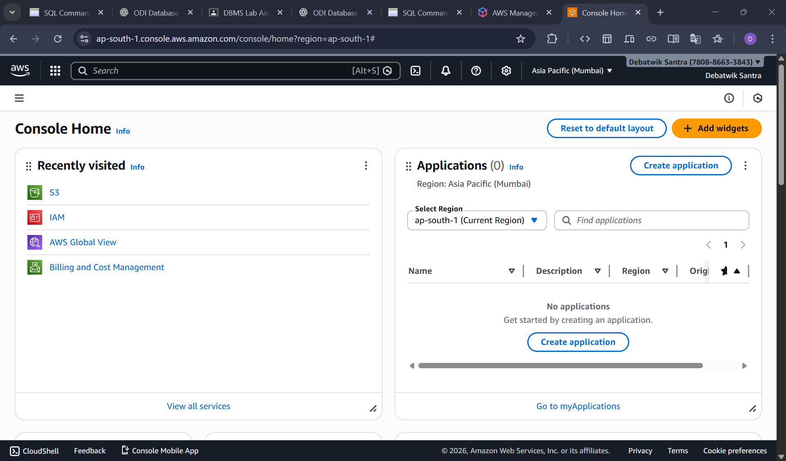
Step 2: Open IAM Service.
In the search bar, type IAM and click on “IAM” at the top of search options.
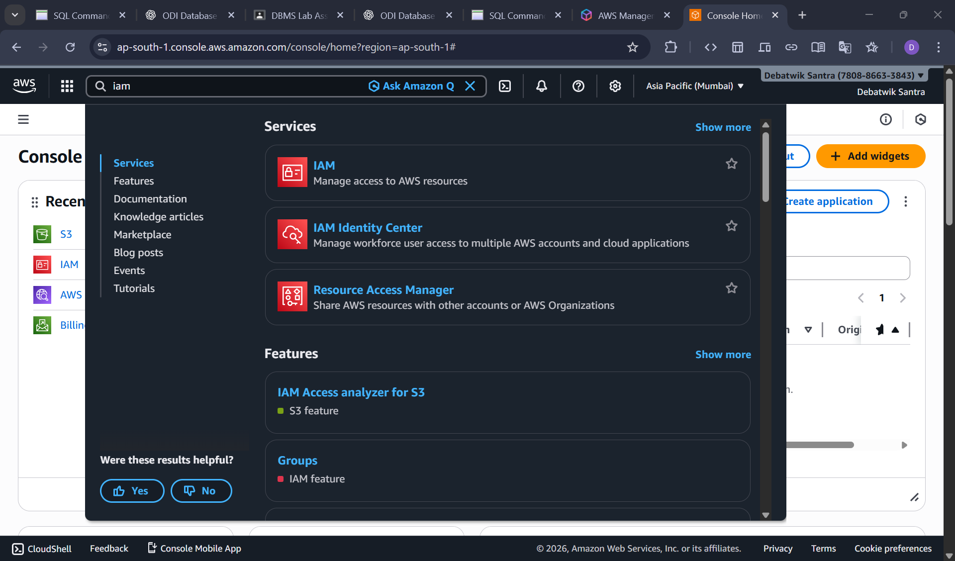
Step 3: Create IAM User
- In IAM left menu, click on the Users. And Then Create on the Create User.

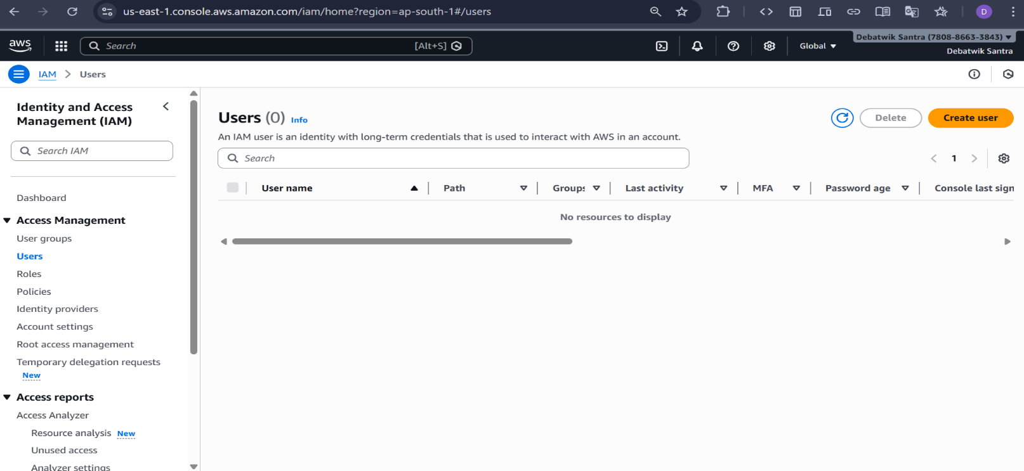
- On the specify user details page, enter.
User name: IAM Piku
- Enable Provide user access to the AWS Management Console.
- Under Console Password select Custom password and enter a password.
- Check the option Users must create a new password at next sign in (Recommended).
- Click on Next to proceed to permission settings.
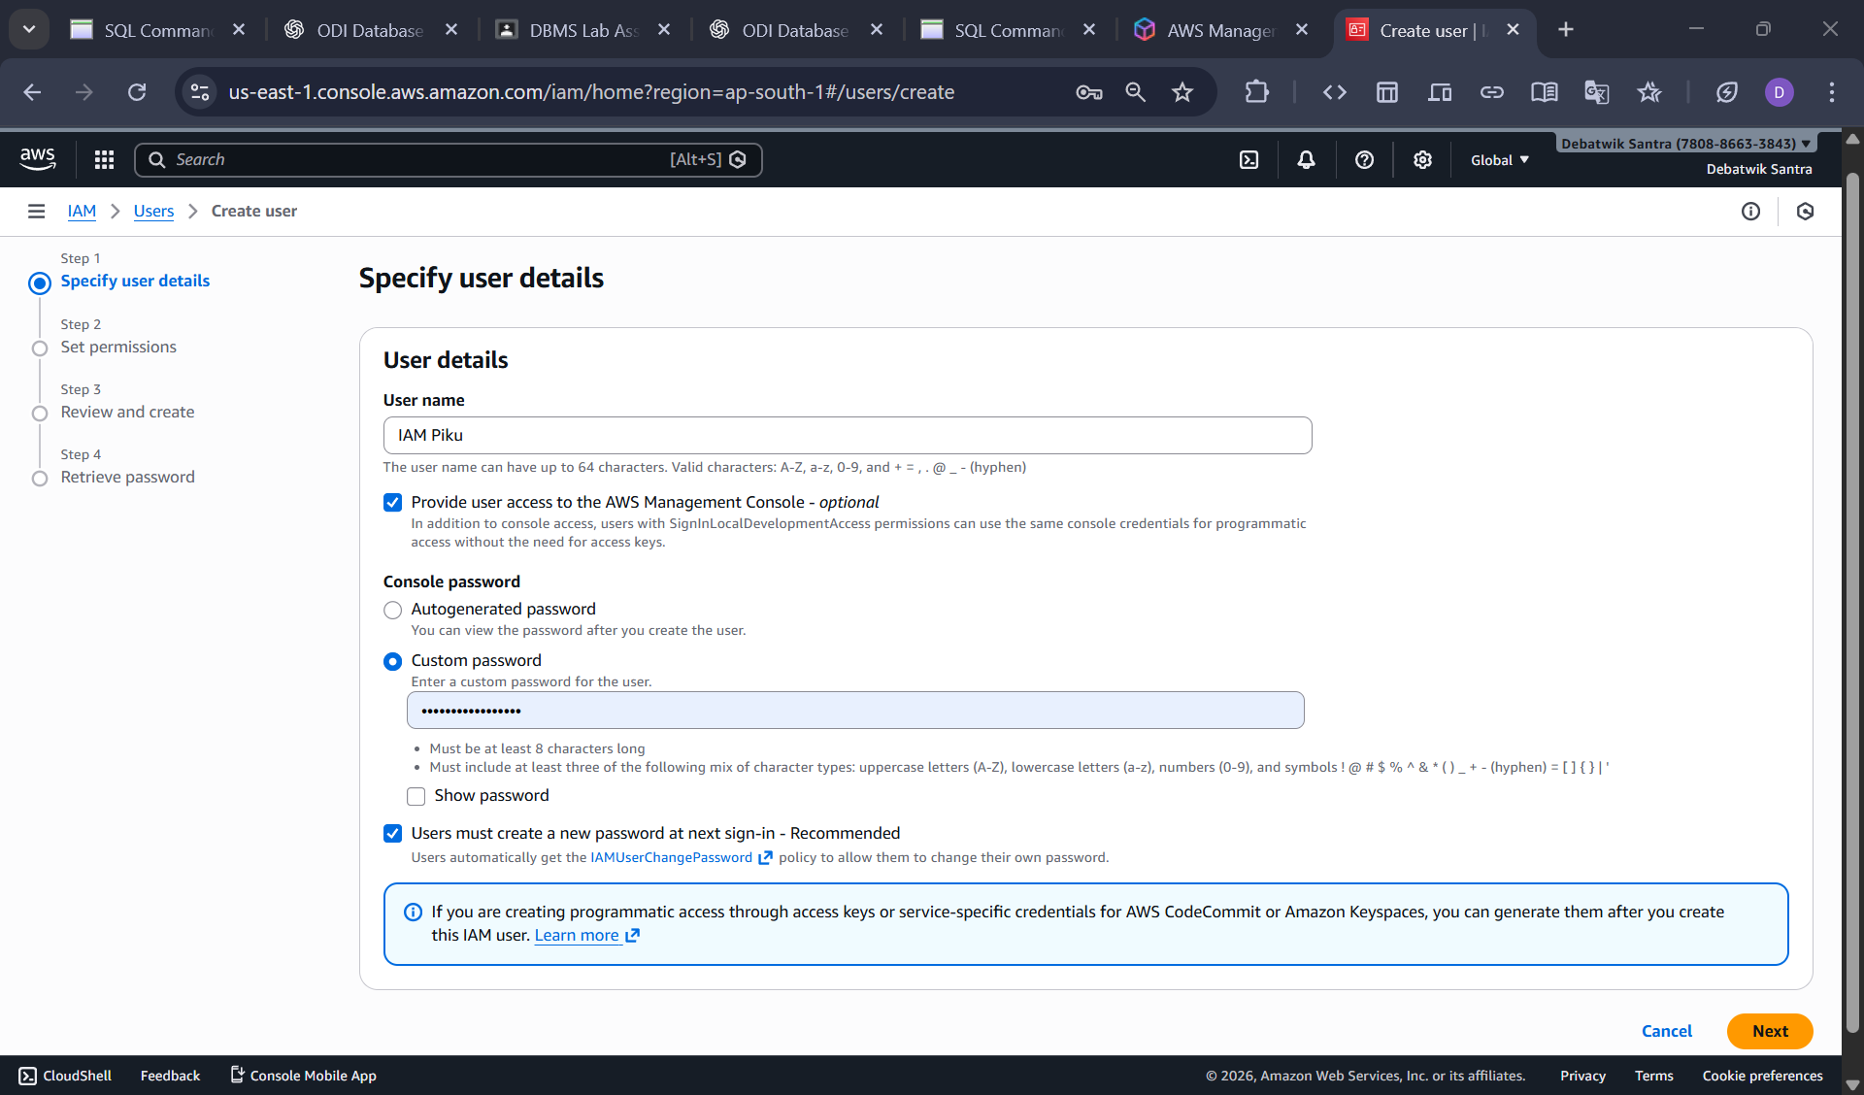
Step 4: Create User Group and Attach S3 Full Acess policy.
- On the Set permissions page during IAM user creation , select Add user to group And Create Group.
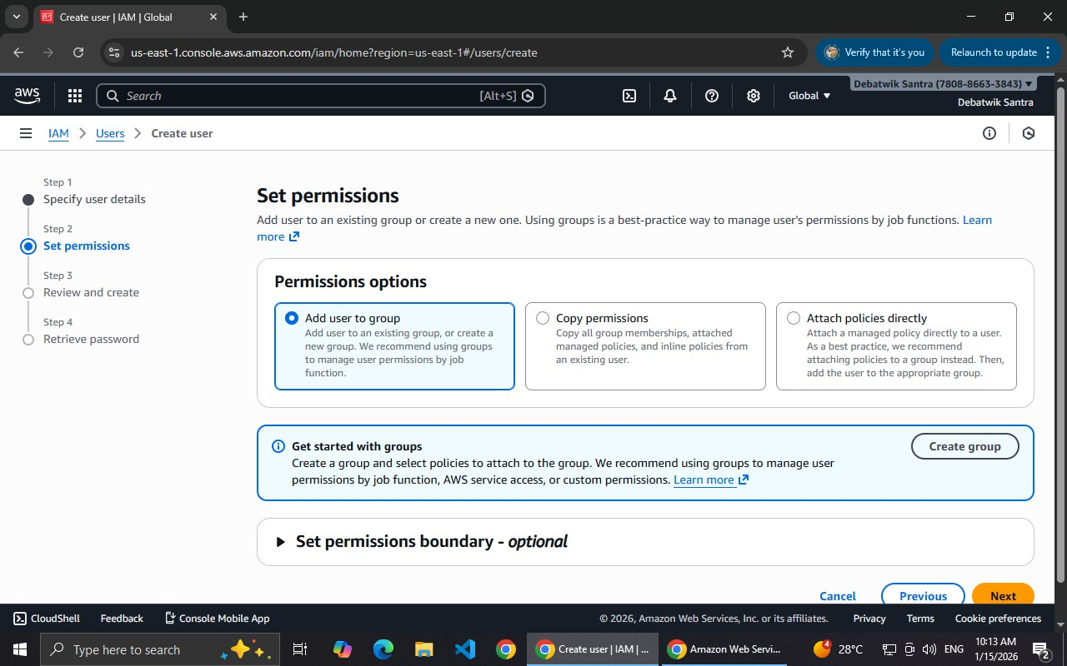
- In the Create user Group window.
- Enter User Group name: Debatwik_S3
- in the Permission policies search box , type S3.
- From the list , Select some policies. And click on Create user group.
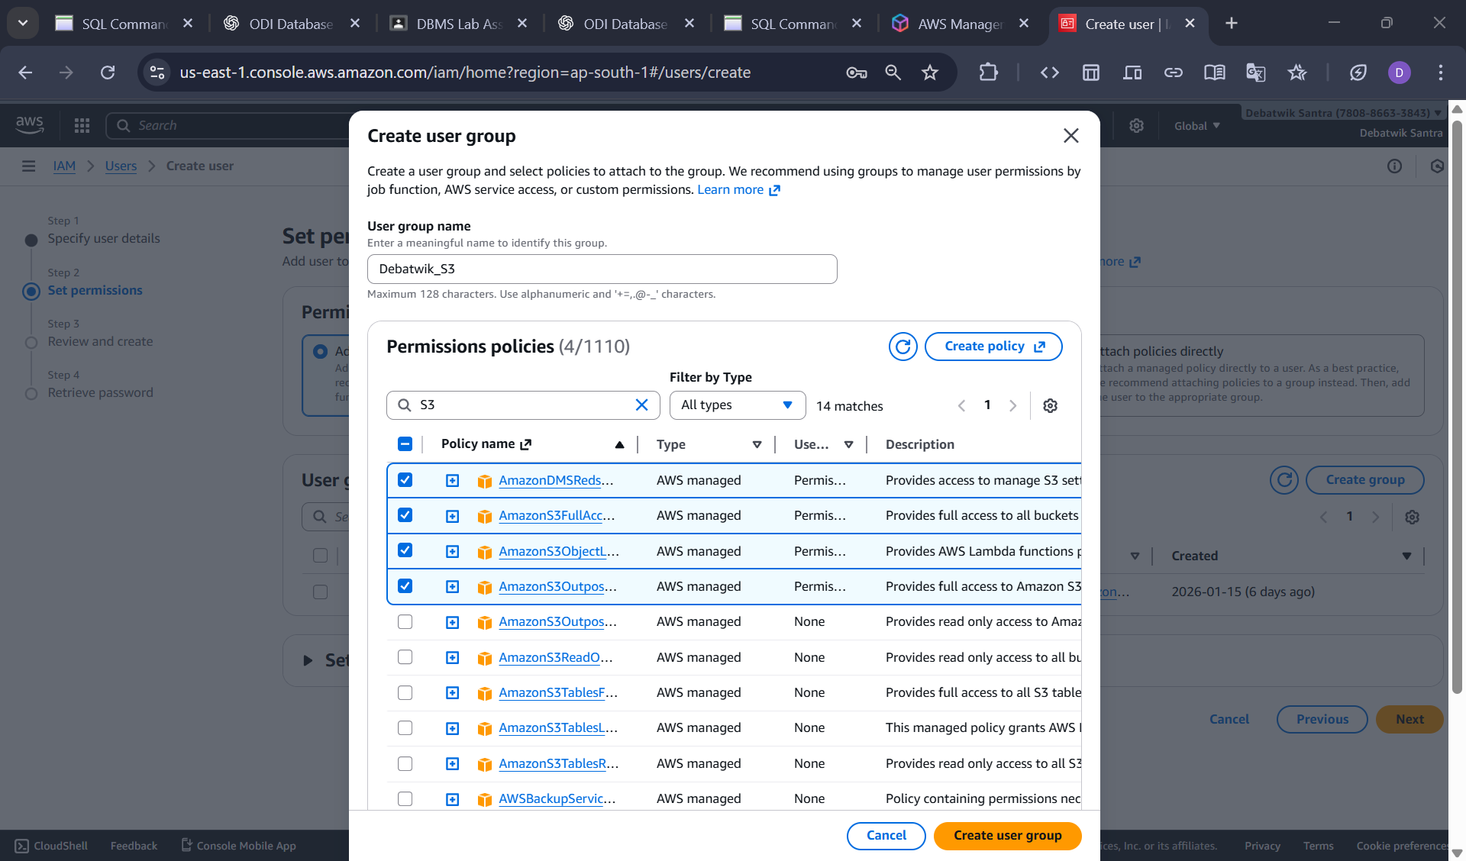
- Ensures the newly created group is Selected.
- Click on the Next to continue user creation.

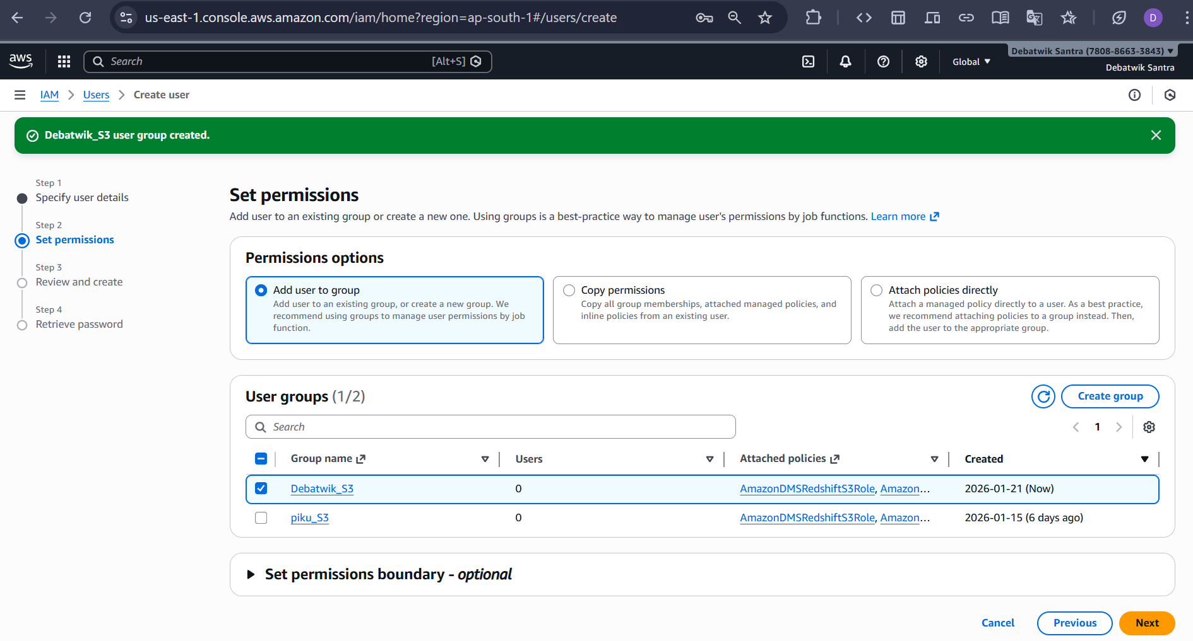
Step 5: Review and Create User
- Review user details and permissions.
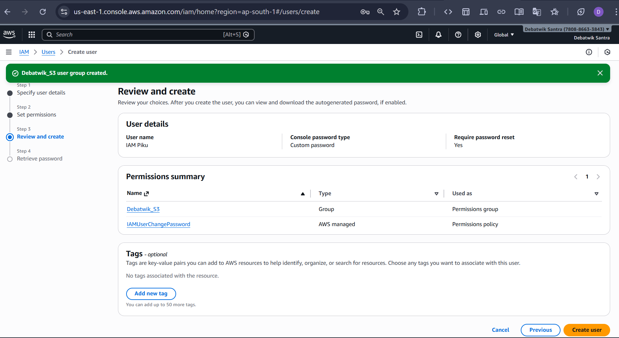
- Click on the Create user.

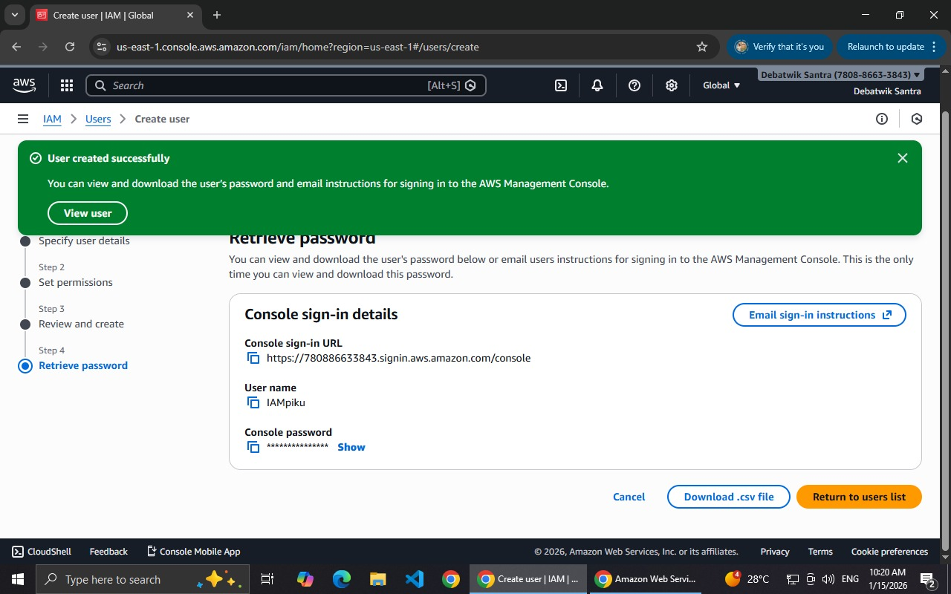
An IAM user successfully created and granted full access to Amazon S3 using the AmazonS3 FullAccess policy.
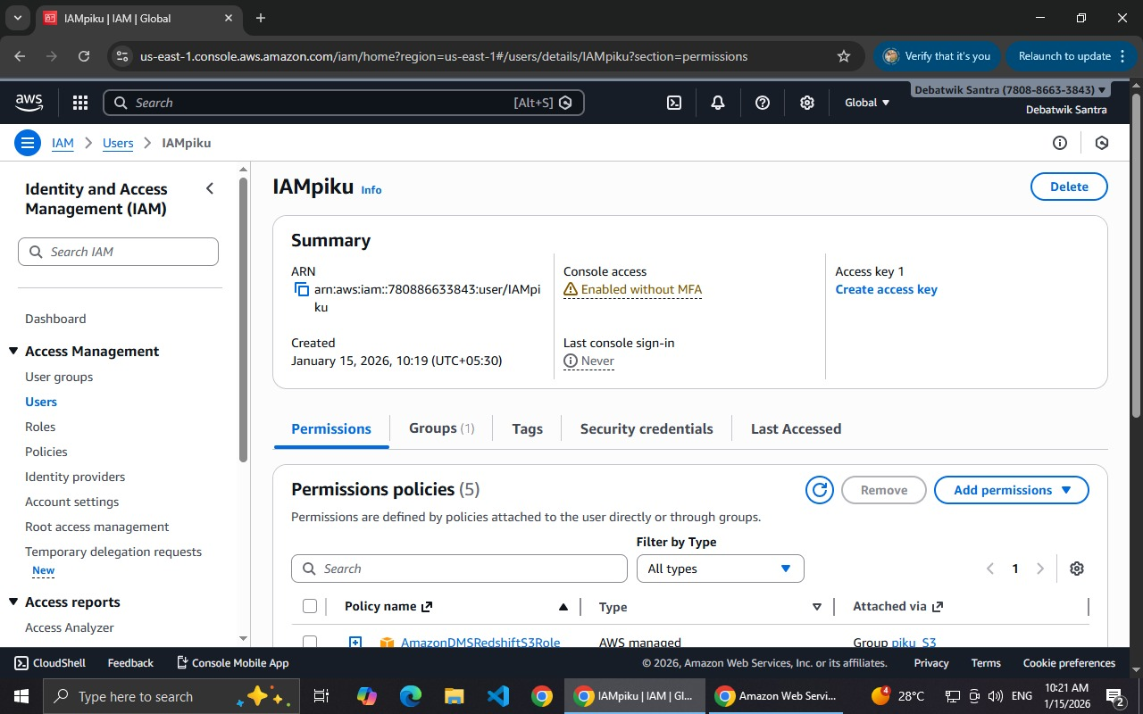
Step 6: Verify IAM User Login in incognito window
- Open a new Incognito/Private window in the browser.
- Go To: https://signin.aws.amazon.com/
- Select IAM User sign in.
- Enter the following details:
Account ID: 780886633843
IAM Username: IAM Piku
Password: (initial IAM user password created by the Root user)
- Click on Sign in.
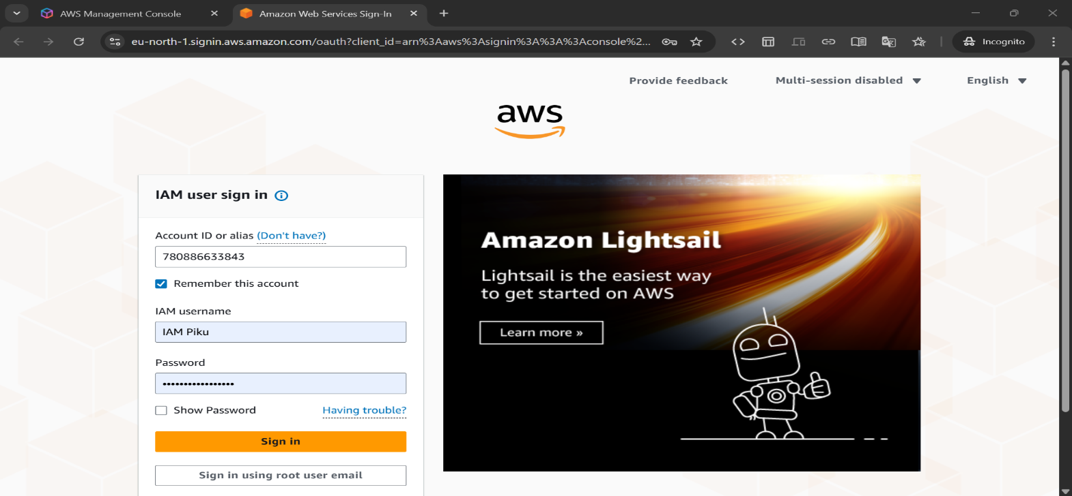
Step 7: Reset IAM User Password (First- Time-Login)
- After Signing in, AWS prompts for Password Reset.
- On the Password reset page:
- Enter Old Password, then Enter New Password then Re-enter Confirm New Password.
- Click Confirm Password Change.
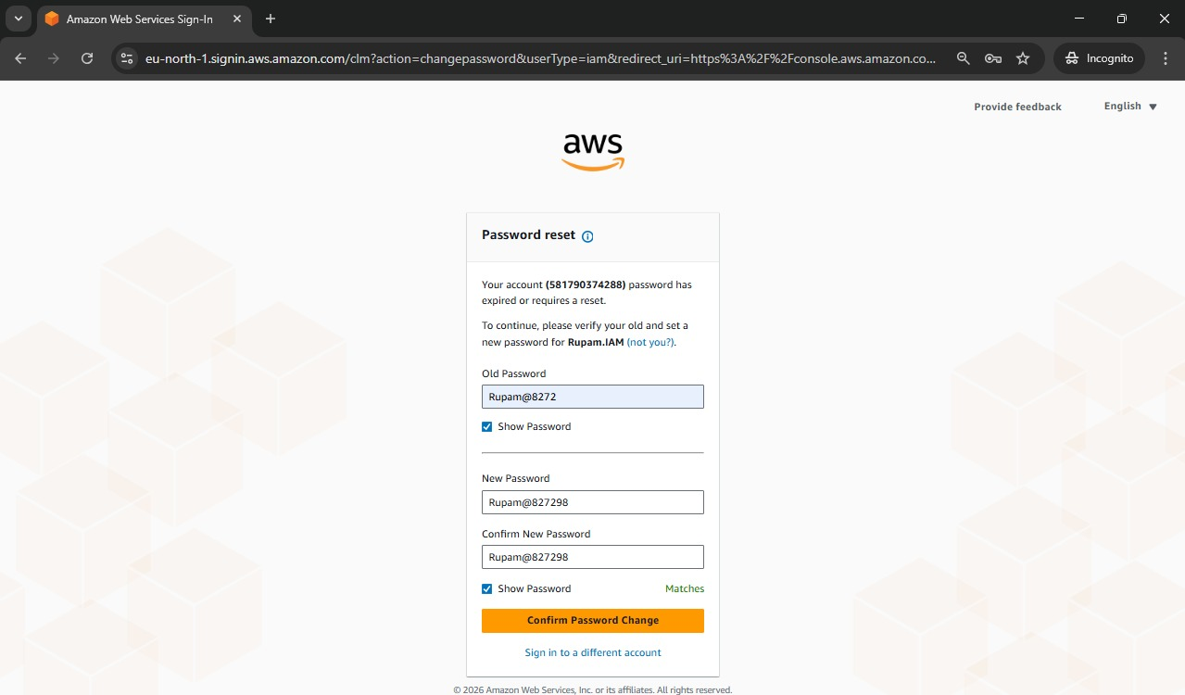
- A confirmation Message Appears Showing Password reset succesfull and click on the Continue to sign in.
Step 8 : Verify IAM User Permissions
- After successful login, IAM user console opens.
- Navigate to services S3.
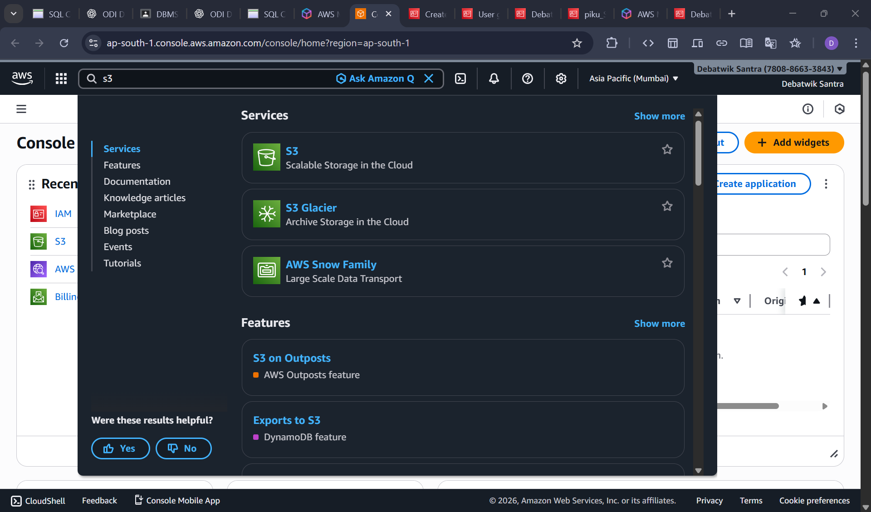
- Verify the user can:
- Access the Amazon S3
- View buckets (as per permissions)
- Confirm permissions are inherited via user Group.
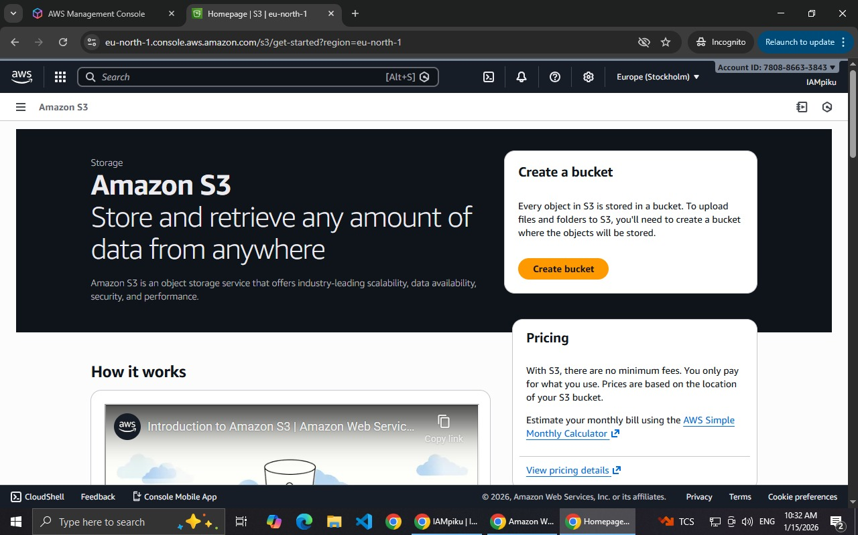
The IAM user IAMpiku was Succesfully created, logged in usong an incognito window , forced to reset password on first login, and verified to have full access to Amazon S3 through a user group.

